1. Draw a Data Flow Diagram (DFD) upto level -2 for an Online Shopping system, illustrating the flow of data between the main processes, data stores, and external entities.

**Level-0:**

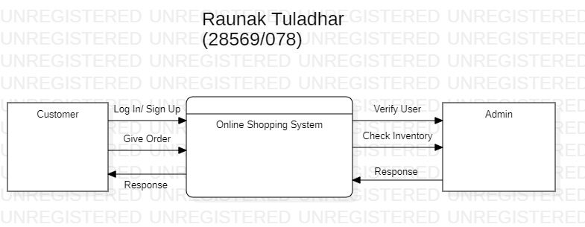

**Level-1:**

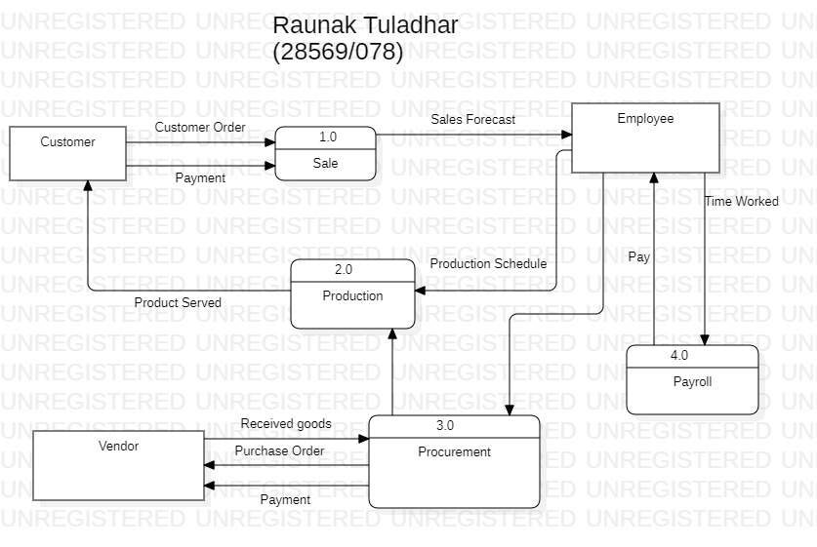

**Level-2:**

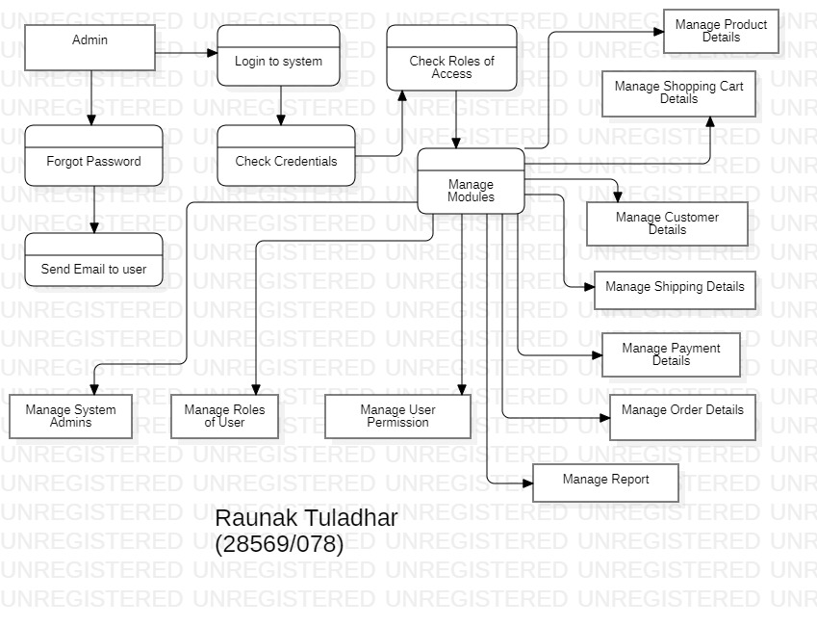

1. Create an E-R Diagram for a Library Management System, highlighting the main entities and relationships.

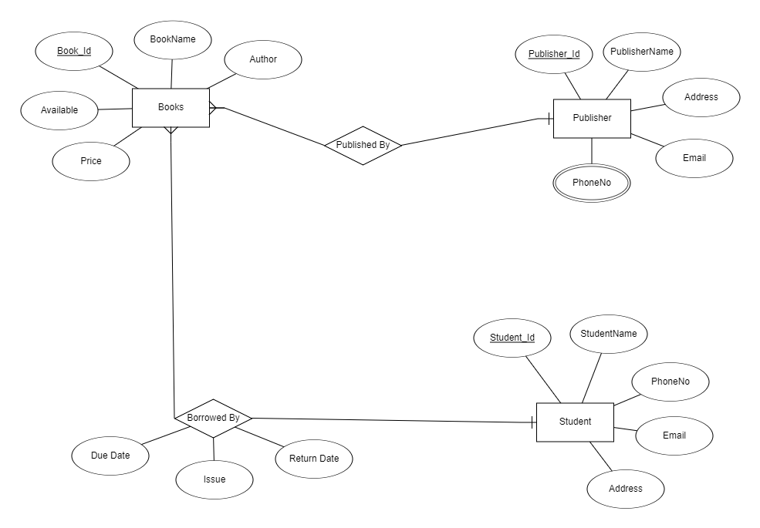

1. Draw a Use Case Diagram for an ATM system, including key actors and use cases.

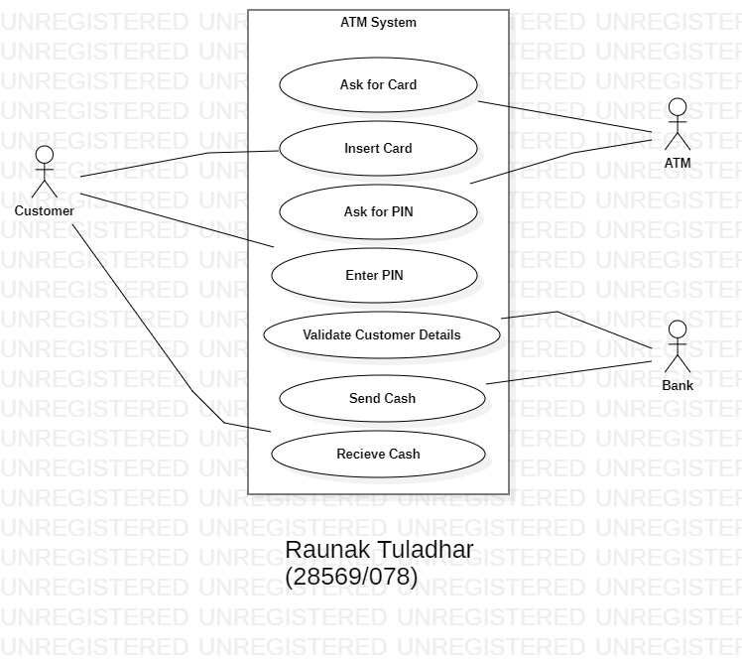

1. Design a Class Diagram for a Hotel Management System, showing the relationships between guests, rooms, and reservations.

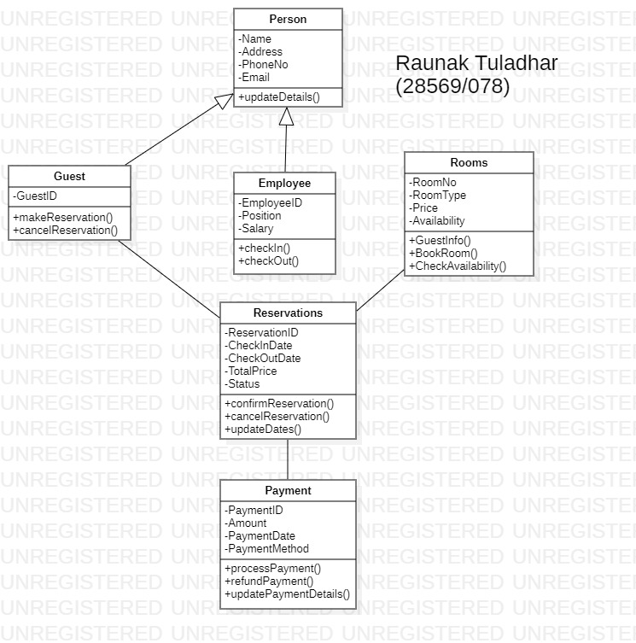

1. Develop a Sequence Diagram for a Hospital Management System to illustrate the interaction between patients, doctors, and medical records.

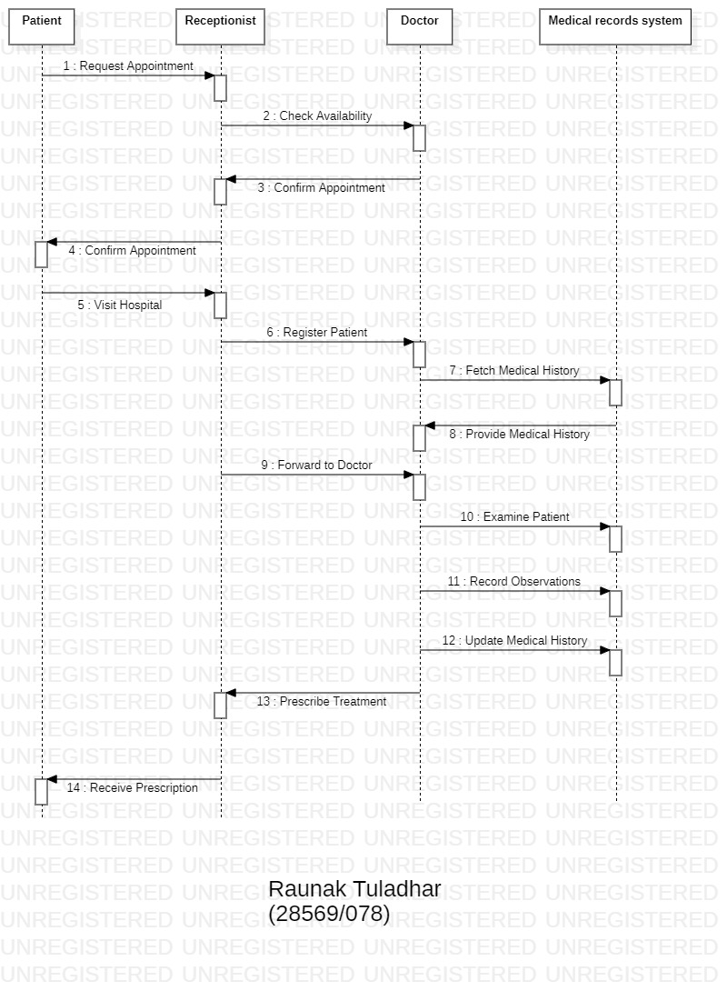

1. Construct an Activity Diagram for a Banking System, detailing the process of handling customer transactions.

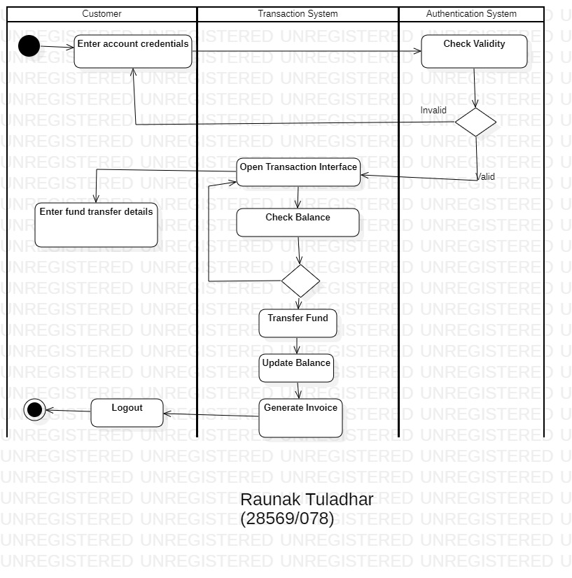

1. Design a Use Case Diagram for a University Registration System, identifying the primary actors and their interactions with the system.

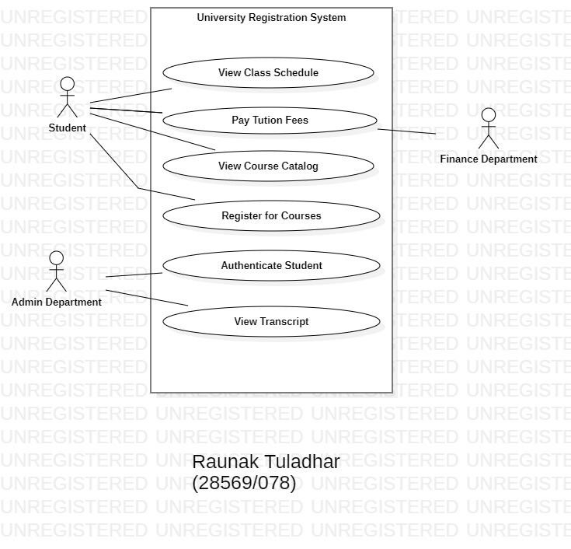

1. Draw an Activity Diagram for an Airline Reservation System to model the steps involved in booking a flight.

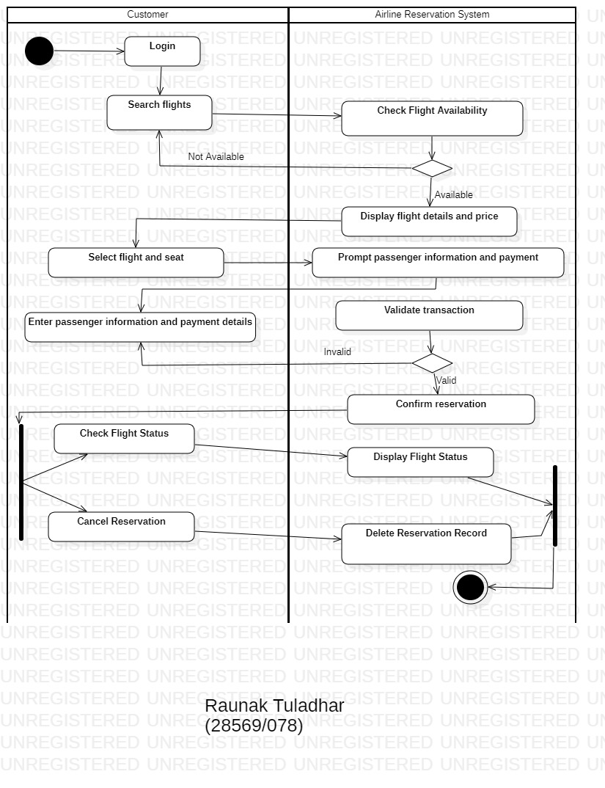

1. Illustrate a Class Diagram for an Airline Reservation System, showing key classes like Passenger, Flight, Booking, and Ticket.

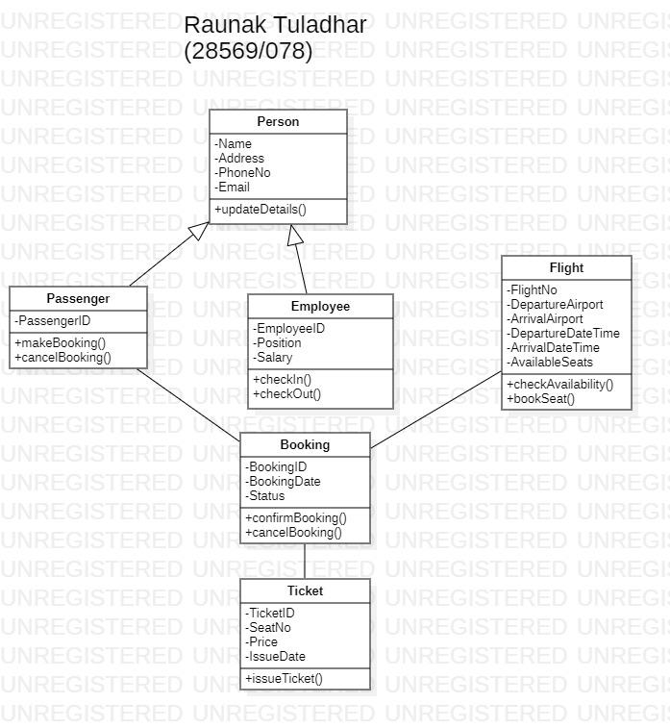

1. Design a Use Case Diagram for a Food Ordering System, highlighting the main functionalities and interactions between users and the system.

